**MAHARAJA SURAJMAL INSTITUTE**

**Affiliated to GGSIP University & NAAC ‘A’ grade accredited**



**DEPARTMENT OF COMPUTER**

**APPLICATIONS**

**WEB TECHNOLOGIES**

**Practical File**

**Subject Code – BCA 175**

**SUBMITTED BY SUBMITTED TO**

**Aman Tripathi Mrs. Nikita Malik**

**111146215262 Associate Professor. MSI**

**1st Sem, 2nd Shift**

| **S.No.** | **Date** | **Content** |
| --- | --- | --- |
| 1. | 16/12/2021 | Create your resume using various basic HTML tags. |
| 2. | 17/12/2021 | Create the timetable of your class using HTML tags. |
| 3. | 23/12/2021 | Create the following unordered/ordered nested list as shown in the figure. |
| 4. | 24/12/2021 | Create a web page with the following specifications:  a) an ordered list containing the names of your friends.  b) an unordered list specifying hobbies.  c) some links to various search engines.  d) links to five different web pages, created by you, opening in a new  window.  e) a link at the top of the page so that when clicked jump all way to the  bottom of the page.  f) a link at the bottom of the page so that when clicked jump all way to the  top of the page. |
| 5. | 30/12/2021 | Create the following table as shown using HTML. |
| 6. | 31/12/2021 | Create the following form in HTML as shown in the figure. |
| 7. | 03/01/2022 | Create an online application form having the following specifications:  a) position applied for(autofocus), name, nationality, gender, date of birth  (Selected from auto picked of a text area), address, telephone number  and email(required), password(required).  b) educational history, qualifications and skills(checkbox).  c) work experience/employment/training in terms of employer history  and number of years of experience selected from a slider. Set max.  years of experience to 10 years.  d) personal statement.  e) two referees including names, occupation, relationship, address,  telephone.  a submit and clear button. |
| 8. | 04/01/2022 | Create a web page showing India's map and create hotspots on five different states and link them to the e-government sites of the respective states. |
| 9. | 05/01/2022 | Create a web page using three frames and link them to an image, audio and  video as shown in the figure. |
| 10. | 06/01/2022 | Create a web page having six frames and link each frame with five different web pages. |
| 11. | 07/01/2022 | Create the following frameset as shown in the figure. |
| 12. | 07/01/2022 | Create an Iframe and write some lines before and after it. |

Practical 1

Code:-

<!DOCTYPE html>

<html lang="en">

<head>

<meta charset="UTF-8" />

<meta http-equiv="X-UA-Compatible" content="IE=edge" />

<meta name="viewport" content="width=device-width, initial-scale=1.0" />

<title>Resume</title>

</head>

<body>

<div>

<center>

<img style="border-radius: 50%" src="Media/Untitled design (3).png" width=" 200px" alt="Pofile" />

</center>

<h2 style="text-align: center">

Aman Tripathi <br />Email:- imamantripathi@gmail.com <br />Contact No.:-

8126406617

</h2>

</div>

<h2 style="padding-left: 100px"><u>Objective</u></h2>

<p style="padding-left: 100px; padding-right: 200px; font-size: medium">

<b>Looking for opportunities to incorporate my skills and training to help

the company grow. I am looking forward to roles that will help me

realise my potential by exploring the various aspects of this field.</b>

</p>

<div style="padding-left: 55px">

<ul>

<h2><u>Education Qualification</u></h2>

<li style="font-size: medium">

<b>10th passed from ICSE Board with 81% (2019) </b>

</li>

<li style="font-size: medium">

<b>I got 100/100 Marks in Computer Applications </b>

</li>

<li style="font-size: medium">

<b>12th passed from ISC Board with 80.8% (2021) </b>

</li>

<li style="font-size: medium">

<b>I received a certificate in code jam 2021 </b>

</li>

</ul>

</div>

<div style="padding-left: 55px">

<ul>

<h2><u>Professional Qualification</u></h2>

<li style="font-size: medium">

<b>Basic Knowledge of Computer </b>

</li>

<li style="font-size: medium">

<b>Complete Knowledge of JAVA </b>

</li>

<li style="font-size: medium">

<b>Complete Knowledge of HTML </b>

</li>

<li style="font-size: medium">

<b>Intermediate Knowledge of CSS </b>

</li>

<li style="font-size: medium">

<b>Basic knowledge of JAVASCRIPT </b>

</li>

</ul>

</div>

<div style="padding-left: 55px">

<ul>

<h2><u>Hobbies</u></h2>

<li style="font-size: medium">

<b>Reading books </b>

</li>

<li style="font-size: medium">

<b>Playing Chess</b>

</li>

<li style="font-size: medium">

<b>Listening Music </b>

</li>

<li style="font-size: medium">

<b>Playing an instrument </b>

</li>

<li style="font-size: medium">

<b>Writing & Art </b>

</li>

</ul>

</div>

<div style="padding-left: 55px">

<ul>

<h2><u>Interests</u></h2>

<li style="font-size: medium">

<b>History(Indian Modern History) </b>

</li>

<li style="font-size: medium">

<b>Website Development</b>

</li>

<li style="font-size: medium">

<b>Travelling </b>

</li>

<li style="font-size: medium">

<b>Research in IT Sector </b>

</li>

<li style="font-size: medium">

<b>Android Development</b>

</li>

<li style="font-size: medium">

<b>Producing or listening music </b>

</li>

</ul>

</div>

<br /><br />

<address style="

font-size: x-large;

font-weight: bold;

text-align: right;

padding-right: 200px;

">

Aman Tripathi

</address>

<br /><br /><br />

</body>

</html>

Output:-

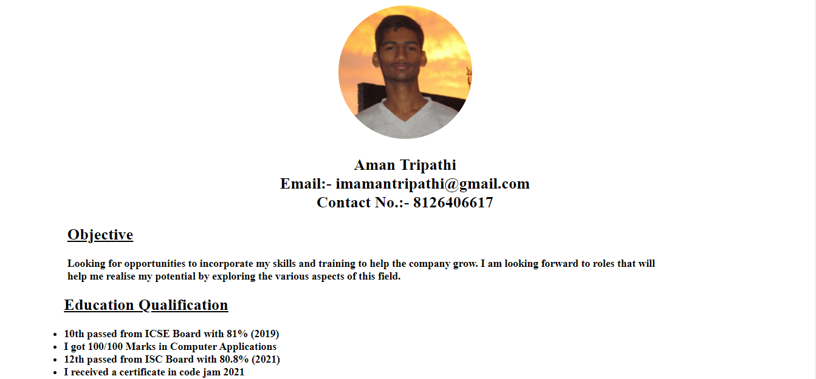

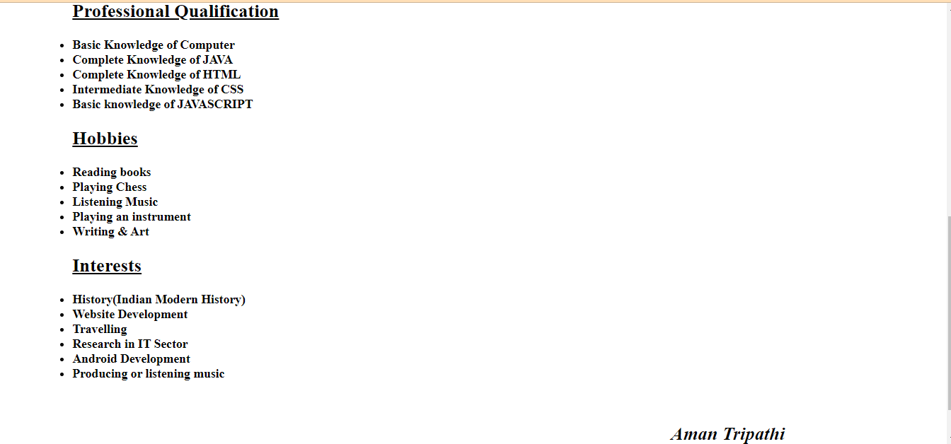

Practical 2

code:-

<html lang="en">

<head>

<meta charset="UTF-8" />

<meta http-equiv="X-UA-Compatible" content="IE=edge" />

<meta name="viewport" content="width=device-width, initial-scale=1.0" />

<title>Collage TimeTable</title>

<style>

* {

padding-top: 25px;

padding-left: 10px;

padding-right: 10px;

margin: 0;

}

table,

th,

td {

border: 2px solid black;

}

table {

border-collapse: collapse;

}

th,

td {

text-align: center;

padding: 5px 20px 5px 20px;

}

div {

padding: 10px 300px 50px 300px;

border: 1px solid black;

border-radius: 10px;

}

caption {

text-decoration: none;

font-weight: bolder;

font-family: "Lucida Sans", "Lucida Sans Regular", "Lucida Grande",

"Lucida Sans Unicode", Geneva, Verdana, sans-serif;

}

</style>

</head>

<body>

<div style="table-layout: fixed">

<table>

<thead>

<caption>

Maharaja Surajmal Institute

<br /><b>Department Of Computer Application</b>

<br />Online Timetable Second Shift (Session:- DEC-MAY 2021)

</caption>

<caption style="padding: 0%; padding-bottom: 20px;">

<u>BCA-FIRST SEM-Secton:A(Second Shift)</u>

<br />Class Coordinator: Ms. Nikita Malik

</caption>

<tr>

<th>DAY/TIME</th>

<th>8:50-9:50</th>

<th>9:55-10:55</th>

<th>11:00-12:00</th>

<th>12:05-01:05</th>

<!-- <th>01:05-01:20</th> -->

<th>01:20-02:20</th>

<th>02:25-03:25</th>

</tr>

</thead>

<tbody>

<tr>

<th>MON</th>

<td>WT</td>

<td>MATHS</td>

<td>TC</td>

<td>C</td>

<td colspan="2">WT/C LAB</td>

</tr>

<tr>

<th>TUE</th>

<td>MATHS</td>

<td>WT</td>

<td colspan="2">WT/C LAB</td>

<td colspan="2">FIT LAB</td>

</tr>

<tr>

<th>WED</th>

<td>C</td>

<td>MATHS</td>

<td>WT</td>

<td>FIT</td>

<td>TC</td>

</tr>

<tr>

<th>THU</th>

<td>TC</td>

<td>C</td>

<td colspan="2">WT/C LAB</td>

<td>FIT</td>

<td>MATHS(A+B Bridge)</td>

</tr>

<tr>

<th>FRI</th>

<td colspan="2">WT/C LAB</td>

<td>C</td>

<td>FIT</td>

<td>TC</td>

<td>WT</td>

</tr>

<tr>

<th>SAT</th>

<td>MATHS</td>

<td>FIT</td>

<td colspan="2">FIT LAB</td>

<td>MATHS(A+B Bridge)</td>

</tr>

</tbody>

</table>

<p style="padding: 0%;">

<b>Maths:-</b>Dr. Jyoti, <b>FIT:-</b>Mr. Suraj Pal Chauhan,

<b>C:-</b>Ms. Minal Dhankar, <br><b>WT:-</b>Ms. Nikita Malik,

<b>TC:-</b>Manju Dhillon, <b>C Lab:-</b> Ms. Minal Dhankar, <br>

<b>FIT Lab:-</b>Mr. Suraj Pal Chauhan / Ms. Kanika Kundu, <b>WT Lab:-</b

>Ms. Nikita Malik

</p>

</div>

</body>

</html>

Output:-

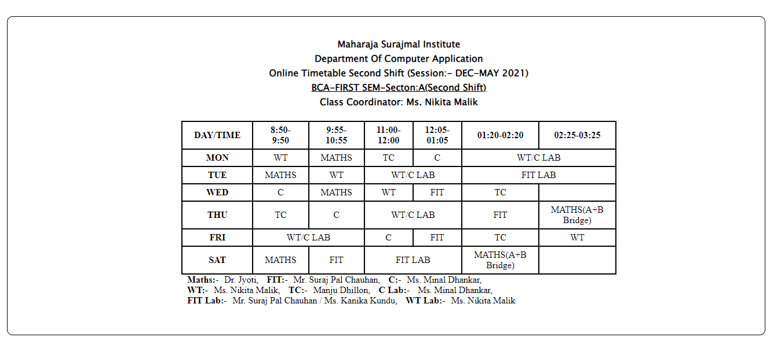

Practical 3

Code:-

<html lang="en">

<head>

<meta charset="UTF-8" />

<meta http-equiv="X-UA-Compatible" content="IE=edge" />

<meta name="viewport" content="width=device-width, initial-scale=1.0" />

<title>List</title>

<style>

body {

align-content: center;

}

div {

font-family: "Lucida Sans", "Lucida Sans Regular", "Lucida Grande",

"Lucida Sans Unicode", Geneva, Verdana, sans-serif;

font-size: medium;

}

</style>

</head>

<body>

<div style="background-color: white">

<h1>Learning Web Development</h1>

<ol type="I">

<li>

Background Skills

<ol type="A">

<li>Unix Commands</li>

<li>Vim Text Editor</li>

</ol>

</li>

<li>

HTML

<ol type="A">

<li>Minimal page</li>

<li>Headings</li>

<li>Tags</li>

<li>

Lists

<ol type="i">

<li>Unordered</li>

<li>Ordered</li>

<li>Definition</li>

<li>Nested</li>

</ol>

</li>

<li>

Links

<ol type="i">

<li>Absolute</li>

<li>Relative</li>

</ol>

</li>

<li>Images</li>

</ol>

</li>

<li>

CSS

<ol type="A">

<li>Anatomy</li>

<li>

Basic Selectors

<ol type="i">

<li>Elements</li>

<li>Class</li>

<li>ID</li>

<li>Group</li>

</ol>

</li>

<li>The DOM</li>

<li>Advanced Selectors</li>

<li>Box Model</li>

</ol>

</li>

<li>

Programming

<ol type="A">

<li>Python</li>

<li>Javascript</li>

</ol>

</li>

<li>

Database

<ol type="A">

<li>Flat File</li>

<li>Relational</li>

</ol>

</li>

</ol>

</div>

</body>

</html>

Output:-

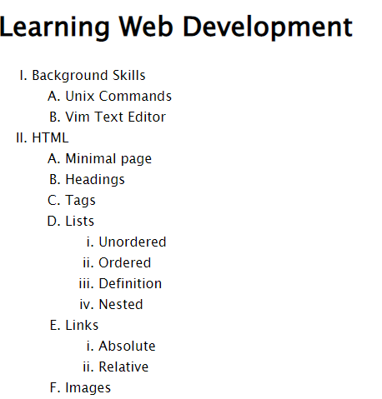

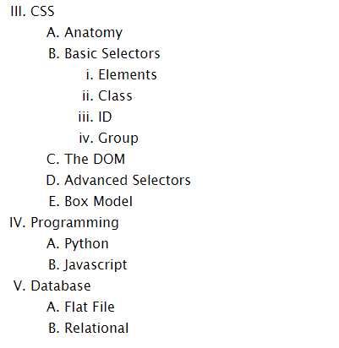

Practical 4

code:-

<html lang="en">

<head>

<meta charset="UTF-8" />

<meta http-equiv="X-UA-Compatible" content="IE=edge" />

<meta name="viewport" content="width=device-width, initial-scale=1.0" />

<title>Practical 4 (Web Page)</title>

<style>

a {

text-decoration: none;

color: black;

}

</style>

</head>

<body>

<div id="top"></div>

<center>

<a href="#bottom" style="color: red; font-weight: bold; font-size: x-large">Go to Bottom Section</a>

</center>

<h3>Name of my friends:</h3>

<ol>

<li>Vipin Buddha</li>

<li>Raj Kumar</li>

<li>Tushar Sharma</li>

<li>Yashu Varshney</li>

<li>Gagan Tripathi</li>

</ol>

<h3>List of my hobbies:</h3>

<ul>

<li>Reading Books</li>

<li>Playing Chess</li>

<li>Traveling</li>

<li>Designing</li>

</ul>

<h3>Links for Various Search Engines:</h3>

<ul>

<li><a target="_blank" href="https://www.google.com/">Google</a></li>

<li><a target="_blank" href="https://www.bing.com/">Bing</a></li>

<li><a target="_blank" href="https://www.baidu.com/">Baidu</a></li>

<li><a target="_blank" href="https://www.yahoo.com/">Yahoo!</a></li>

<li><a target="_blank" href="https://yandex.com/">Yandex</a></li>

<li><a target="_blank" href="https://www.ask.com/">Ask</a></li>

</ul>

<h3>List of Diffrent Webpages:</h3>

<ul>

<li>

<a target="_blank" href="Resume_Practical_1.html">Practical 1 (Resume)</a>

</li>

<li>

<a target="_blank" href="TimeTable_Practical_2.html">Practical 2 (Timetable)</a>

</li>

<li>

<a target="_blank" href="List_Practical_3.html">Practical 3 (List)</a>

</li>

<li>

<a target="_blank" href="Webpage_Practical_4.html">Practical 4 (Webpage)</a>

</li>

<li>

<a target="_blank" href="Table_Practical_5.html">Practical 5 (Image_Table)</a>

</li>

<li>

<a target="_blank" href="Form_Practical_6.html"> Practical 6 (Form)</a>

</li>

</ul>

<center>

<a href="#top" style="color: red; font-weight: bold; font-size: x-large">Go to Top Section</a>

</center>

<div id="bottom"></div>

</body>

</html>

Output:-

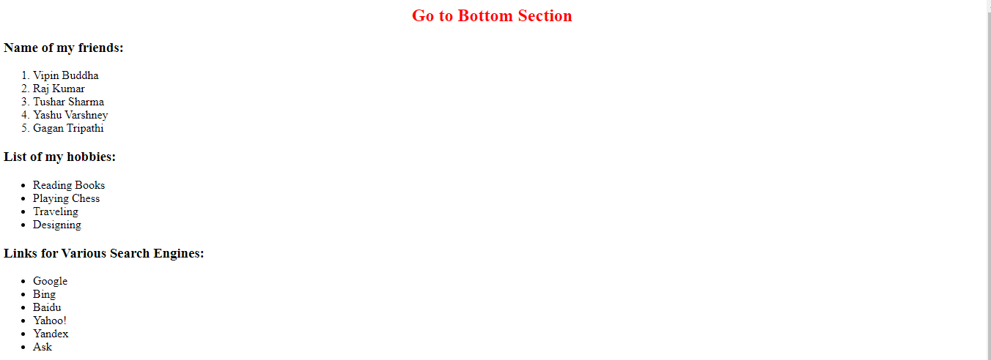

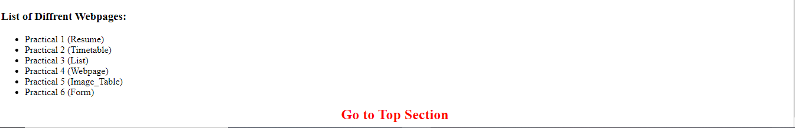

Practical 5

Code:-

<html lang="en">

<head>

<meta charset="UTF-8" />

<meta http-equiv="X-UA-Compatible" content="IE=edge" />

<meta name="viewport" content="width=device-width, initial-scale=1.0" />

<title>Document</title>

<style>

td {

border: 1px solid black;

}

table {

border: 5px solid black;

}

div {

padding: 20px 400px 20px 350px;

}

</style>

</head>

<body>

<div>

<table>

<tbody>

<tr>

<td>

<img

src="Media/IMG_20210227_003056_487.jpg"

width="150px"

alt="Image"

/>

</td>

<td>

<img

src="Media/IMG_20210325_205201_770.jpg"

width="150px"

alt="Image"

/>

</td>

<td>

<img

src="Media/IMG_20210506_080037_099.jpg"

width="150px"

alt="Image"

/>

</td>

<td>

<img

src="Media/IMG_20210510_171515_975.jpg"

width="150px"

alt="Image"

/>

</td>

</tr>

<tr>

<td>

<img

src="Media/IMG_20210519_120425_393.jpg"

width="150px"

alt="Image"

/>

</td>

<td

colspan="2"

style="

text-align: center;

font-size: larger;

font-family: cursive;

background: goldenrod;

"

>

Table with Images

</td>

<td>

<img

src="Media/IMG_20210227_003056_487.jpg"

width="150px"

alt="Image"

/>

</td>

</tr>

<tr>

<td>

<img

src="Media/IMG_20210325_205201_770.jpg"

width="150px"

alt="Image"

/>

</td>

<td>

<img

src="Media/IMG_20210506_080037_099.jpg"

width="150px"

alt="Image"

/>

</td>

<td>

<img

src="Media/IMG_20210510_171515_975.jpg"

width="150px"

alt="Image"

/>

</td>

<td>

<img

src="Media/IMG_20210519_120425_393.jpg"

width="150px"

alt="Image"

/>

</td>

</tr>

</tbody>

</table>

</div>

</body>

</html>

Output:-

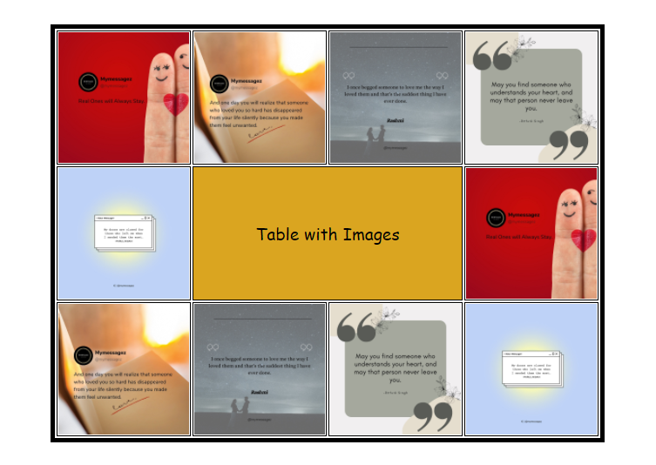

Practical 6

Code:-

<html lang="en">

<head>

<meta charset="UTF-8" />

<meta http-equiv="X-UA-Compatible" content="IE=edge" />

<meta name="viewport" content="width=device-width, initial-scale=1.0" />

<title>Form</title>

<style>

form{

font-family: Cambria, Cochin, Georgia, Times, 'Times New Roman', serif;

font-size: larger;

font-weight: bold;

text-align: left;

padding: auto;

}

</style>

</head>

<body>

<hr />

<h2

style="

font-family: 'Franklin Gothic Medium', 'Arial Narrow', Arial, sans-serif;

text-align: center;

"

>

COMPUTER SOCIETY OF INDIA ANNUAL CONVENTION 2022 PARTICIPANTS RECORD

</h2>

<hr />

<div>

<form action="form.php">

<label for="name"> 1. Name of Participant: </label>

<input type="text" id="name" placeholder="Enter Your Name" />

<br />

<br />

<label for="address"> 2. Address: Street </label>

<input type="text" id="address" placeholder="Street Name" />

<label for="town"> Town </label>

<input type="text" id="town" placeholder="Town Name" />

<br /><br />

<label for="state">State</label>

<input type="text" id="state" placeholder="State Name" />

<label for="pincode">Pincode</label>

<input type="number" id="pincode" placeholder="Enter Pincode " />

<br /><br />

<label for="work">3. Select the work you are involved:</label>

<select name="work" id="work">

<option value="no-work">Select your choice</option>

<option value="Computer Education">Computer Education</option>

<option value="Website Development">Website Development</option>

<option value="Application Development">

Application Development

</option>

</select>

<br /><br />

<label for="tutorial">4. Select any tutorial you with to Attend:</label>

<br />

<label for="Tutorial"> 16<sup>th</sup> April 2022</label>

<select name="tutorial" id="tutorial">

<option value="no-option">Select your choice</option>

<option value="E-commerce">E-commerce</option>

<option value="web Tech">Website Technology</option>

<option value="Android Development">Android Development</option>

<option value="Digital Marketing">Digital Marketing</option>

</select>

<label for="Tutorial"> 17<sup>th</sup> April 2022</label>

<select name="tutorial" id="tutorial">

<option value="no-option">Select your choice</option>

<option value="E-commerce">E-commerce</option>

<option value="web Tech">Website Technology</option>

<option value="Android Development">Android Development</option>

<option value="Digital Marketing">Digital Marketing</option>

</select>

<br /><br />

<label for="requirements">5. Type any of your requirements in the Box:</label>

<br />

<textarea rows="10" cols="30" id="requirements"></textarea>

<br /><br />

<input type="reset" value="Start over" />

<input type="submit" value="Send over" />

</form>

</div>

</body>

</html>

Output:-

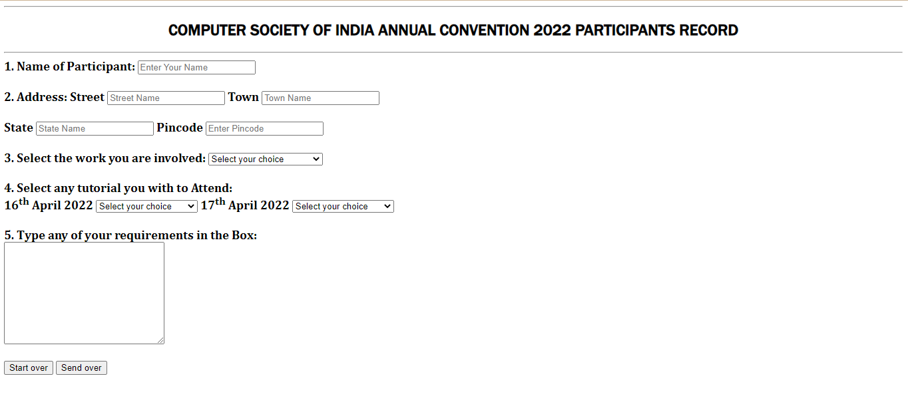

Practical 7

Code:-

<html lang="en">

<head>

<meta charset="UTF-8" />

<meta http-equiv="X-UA-Compatible" content="IE=edge" />

<meta name="viewport" content="width=device-width, initial-scale=1.0" />

<title>Online Application Form</title>

</head>

<body>

<h2

style="

font-family: 'Franklin Gothic Medium', 'Arial Narrow', Arial, sans-serif;

text-align: center;

"

>

Online Application Form

</h2>

<div>

<form action="/form.php">

<label for="position">Position Applied For:</label

><input type="text" autofocus id="position" /> <br /><br />

<label for="name">Enter Your Name:</label>

<input type="text" id="name" placeholder="" />

<br /><br />

<label for="nationality">Enter Your Nationality:</label>

<input type="text" name="nationality" id="nationality" /><br /><br />

<label for="gender">Select Your Gender:</label><br />

<input type="radio" name="gender" value="male" /> Male<br />

<input type="radio" name="gender" value="female" /> Female<br />

<input type="radio" name="gender" value="other" /> Other

<br />

<br />

<label for="dob">Date Of Birth:</label>

<input type="date" id="dob" name="dateofbirth" value="" min="" max="" />

<br />

<br />

<label for="address">Enter Your Address:</label>

<textarea name="address" id="address" cols="20" rows="5"></textarea>

<br /><br />

<label for="telephone_number">Enter Your Number:</label>

<input type="number" name="number" id="telephone_number" /> <br /><br />

<label for="Email"> Enter Your Email: </label>

<input type="email" required name="email" id="Email" />

<br /><br />

<label for="passward">Enter Your Password:</label>

<input type="password" name="passward" required id="passward" />

<br /><br />

<label for="education">Educational History:</label><br />

<input type="checkbox" name="12th" id="education" />12th Class Student

<br />

<input type="checkbox" name="BCA" id="education" />BCA Student

<br /><br />

<label for="qualification">Qualification:</label><br />

<input type="checkbox" name="12th pass" id="qualification" />12th Pass

<br />

<input type="checkbox" name="undergraduate" id="qualification" /> Under

Graduate <br />

<input type="checkbox" name="graduate" id="qualification" /> Graduate

<br />

<input type="checkbox" name="postgraduate" id="qualification" /> Post

Graduate <br />

<input type="checkbox" name="doctorate" id="qualification" /> Doctorate

<br /><br />

<label for="skills">Skills:</label><br />

<input type="checkbox" name="Web Development" id="skills" />Web

Development<br />

<input type="checkbox" name="App Development" id="skills" />App

Development <br />

<input

type="checkbox"

name="BlockChain Development"

id="skills"

/>BlockChain Development<br />

<input

type="checkbox"

name="Software Development"

id="skills"

/>Software Development<br />

<br /><br />

<label for="work experience"

>Work Experience/Employment/Training:</label

>

<input

type="number"

name="work-exprience"

min="0"

max="10"

id="work experience"

/>

<br /><br />

<label for="personal-statement">Personal Statement:</label>

<textarea

name="personal statement "

id="personal-statement"

cols="30"

rows="5"

></textarea>

<div>

<h3>Referee 1</h3>

<label for="name">Name:</label>

<input type="text" id="name" placeholder="" /><br /><br />

<label for="occupation">Occupation:</label>

<input type="text" id="occupation" placeholder="" /><br /><br />

<label for="relation">Relationship:</label>

<input type="text" id="relation" placeholder="" /><br /><br />

<label for="address">Address:</label>

<textarea name="address" id="address" cols="20" rows="5"></textarea

><br /><br />

<label for="name">Telephone:</label>

<input type="text" id="name" placeholder="" />

<br /><br />

<br /><br />

</div>

<div>

<h3>Referee 2</h3>

<label for="name">Name:</label>

<input type="text" id="name" placeholder="" /><br /><br />

<label for="occupation">Occupation:</label>

<input type="text" id="occupation" placeholder="" /><br /><br />

<label for="relation">Relationship:</label>

<input type="text" id="relation" placeholder="" /><br /><br />

<label for="address">Address:</label>

<textarea name="address" id="address" cols="20" rows="5"></textarea

><br /><br />

<label for="name">Telephone:</label>

<input type="text" id="name" placeholder="" />

<br /><br />

<br /><br />

</div>

<div class="controls">

<input type="reset" value="Reset" />

<input type="submit" value="Submit" />

</div>

</form>

</div>

</body>

</html>

Output:-

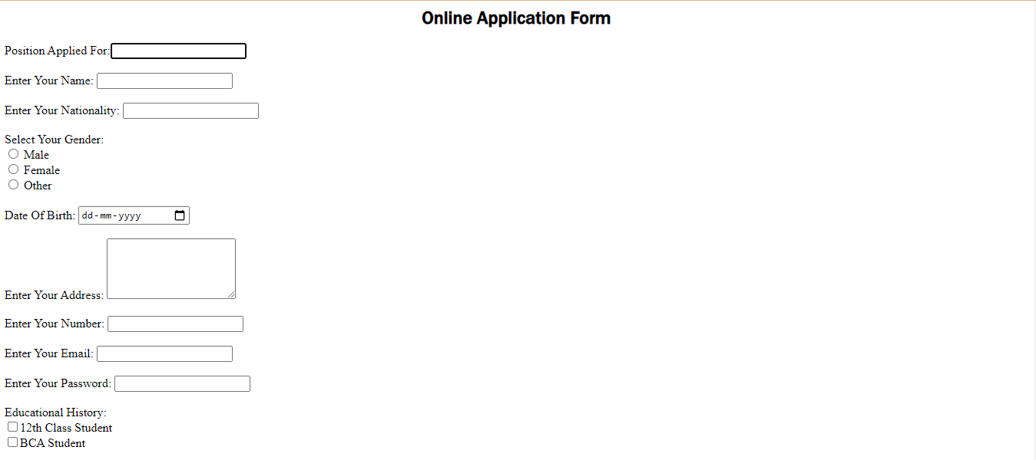



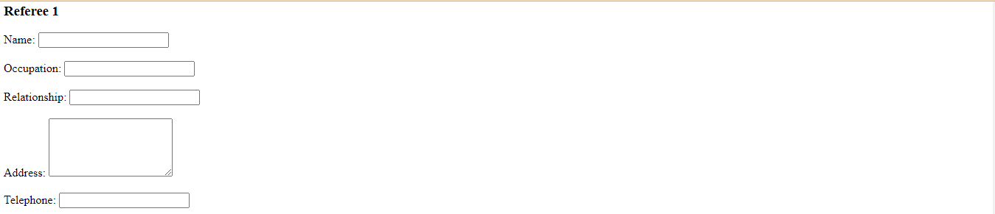

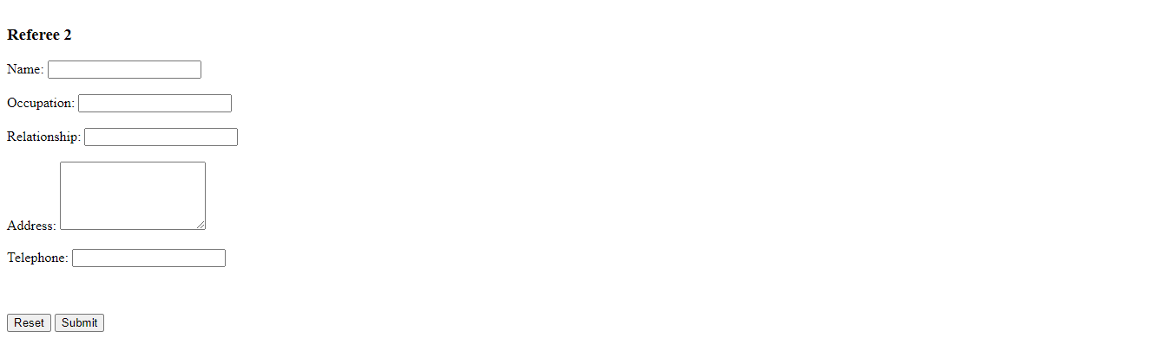

Practical 8

Code:-

<html lang="en">

<head>

<meta charset="UTF-8" />

<meta http-equiv="X-UA-Compatible" content="IE=edge" />

<meta name="viewport" content="width=device-width, initial-scale=1.0" />

<title>Image Map</title>

</head>

<body>

<img

src="Media/indiamap.png"

alt="Map Of India "

usemap="#indiamap"

width=""

/>

<map name="indiamap">

<area

target="_blank"

alt="Uttar Pradesh"

title="Uttar Pradesh"

href="https://edistrict.up.gov.in/edistrictup/"

coords="1319,867,897,689,1013,922,1116,1017,1281,1091,1328,933,1321,902,1321,885,897,728,1022,973,1109,992,916,832"

shape="poly"

/>

<area

target="_blank"

alt="Rajasthan"

title="Rajasthan"

href="https://rajasthan.gov.in/"

coords="703,1169,938,900,709,675,450,827,443,955,612,1062,650,1104"

shape="poly"

/>

<area

target="_blank"

alt="Uttarakhand"

title="Uttarakhand"

href="https://edistrict.uk.gov.in/"

coords="936,647,1072,748,1122,664,1059,596,991,590,975,627"

shape="poly"

/>

<area

target="_blank"

alt="Jammu &amp; Kashmir"

title="Jammu &amp; Kashmir"

href="https://www.jk.gov.in/jkeservices/"

coords="652,176,788,132,865,205,911,246,973,249,955,260,1019,233,1072,246,1070,326,1048,356,1028,363,1010,381,1008,400,1037,427,1039,447,1039,471,1026,480,1013,480,991,471,964,469,933,444,909,447,881,433,856,433,834,436,823,447,806,473,786,484,746,471,716,449,698,433,678,420,709,301,709,275,685,249,656,218,623,209"

shape="poly"

/>

<area

target="_blank"

alt="Panjab"

title="Panjab"

href="http://edistrict.punjabgovt.gov.in/eda/landing.aspx"

coords="755,517,795,510,812,524,819,543,830,563,852,581,861,596,872,623,867,636,856,647,841,651,828,664,821,680,799,675,784,677,757,669,716,660,694,655,689,629"

shape="poly"

/>

</map>

</body>

</html>

Output:-

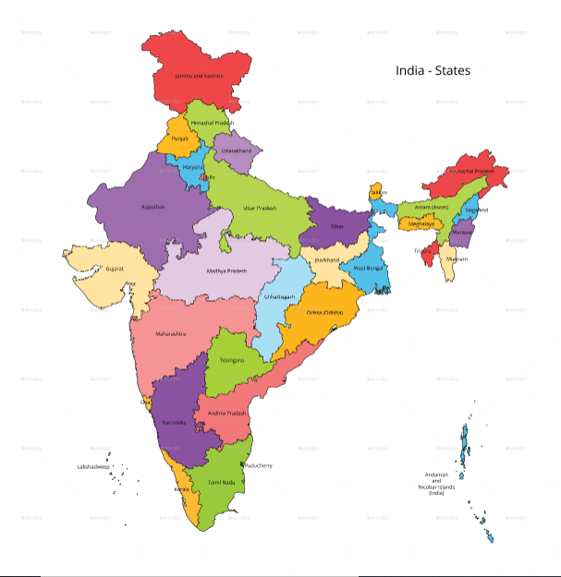

Practical 9

Code:-

<html lang="en">

<head>

<meta charset="UTF-8" />

<meta http-equiv="X-UA-Compatible" content="IE=edge" />

<meta name="viewport" content="width=device-width, initial-scale=1.0" />

<title>Frames</title>

<style>

iframe{

padding: 0;

margin: 0;

}

div

{

text-align: center;

}

</style>

</head>

<body>

<div>

<iframe

src="Media/audio.mp3"

width="80%"

height="250"

frameborder="1"

style="background: brown;"

allowfullscreen=""

allow="fullscreen; picture-in-picture"

></iframe>

<iframe src="Media/4.png" style="display: inline-block;" width="33%" height="40%" frameborder="1"></iframe>

<iframe src="Media/video.mp4" width="46.3%" height="40%" frameborder="1"></iframe>

</div>

</body>

</html>

Output:-

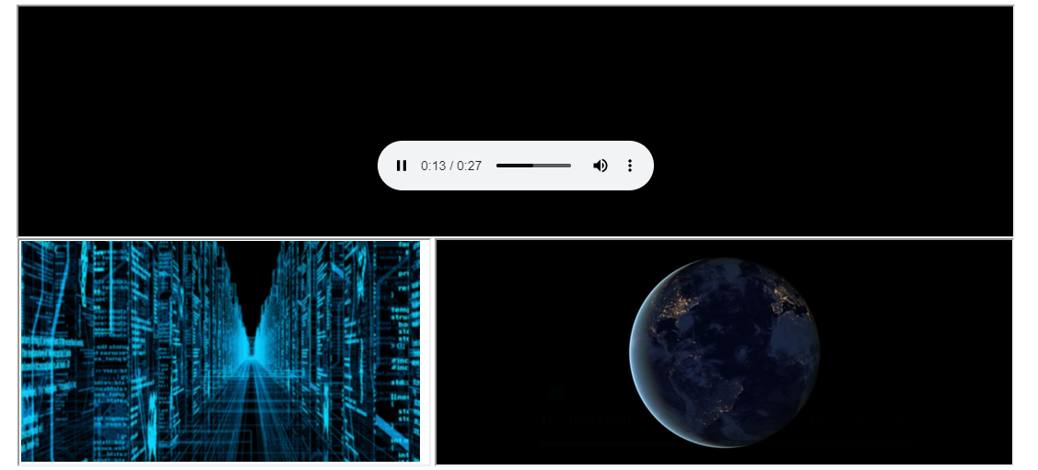

Practical 10

Code:-

<html lang="en">

<head>

<meta charset="UTF-8">

<meta http-equiv="X-UA-Compatible" content="IE=edge">

<meta name="viewport" content="width=device-width, initial-scale=1.0">

<title> 6 Frames</title>

<style>

iframe

{

margin: 5%;

height: 500;

margin-left: 0;

margin-right: 0;

}

</style>

</head>

<body>

<iframe

src="https://www.nerdsflow.com/"

width="100%"

height="300"

style="border: 2px solid black;"

>

</iframe><iframe

src="https://www.tusharojha.com/"

width="100%"

height="300"

style="border: 2px solid black"

>

</iframe><iframe

src="https://www.ranveer.com/"

width="100%"

height="300"

style="border: 2px solid black"

>

</iframe><iframe

src="https://www.bps.in/"

width="100%"

height="300"

style="border: 2px solid black"

>

</iframe><iframe

src="https://www.expert.ai/"

width="100%"

height="300"

style="border: 2px solid black"

>

</iframe><iframe

src="https://www.britannica.com/topic/history"

width="100%"

height="300"

style="border: 2px solid black"

>

</iframe>

</body>

</html>

Output:-



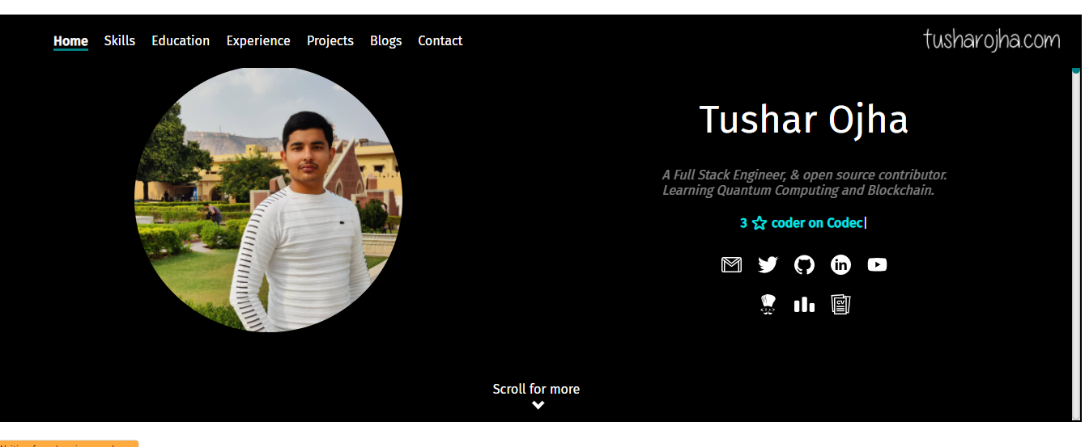

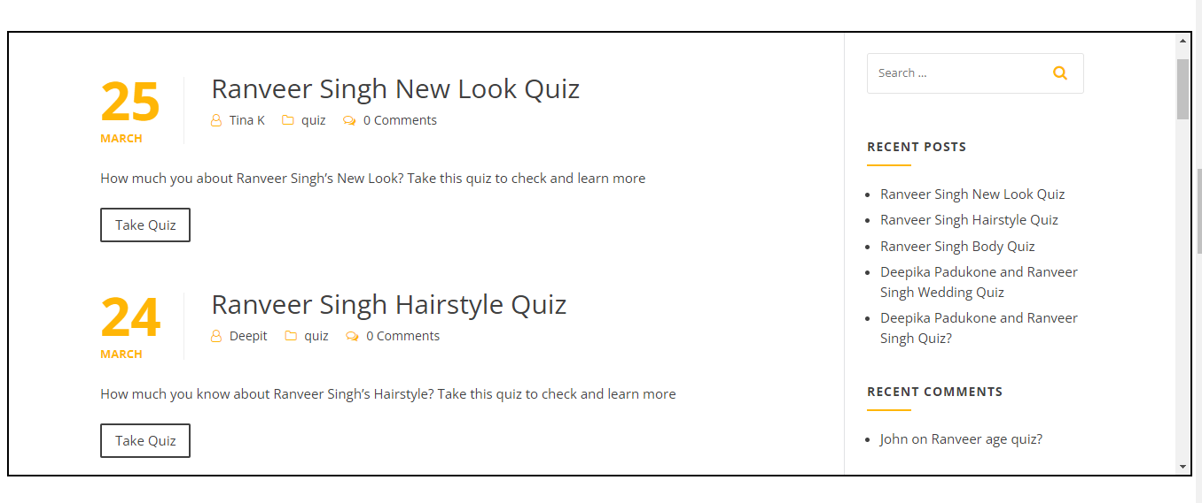

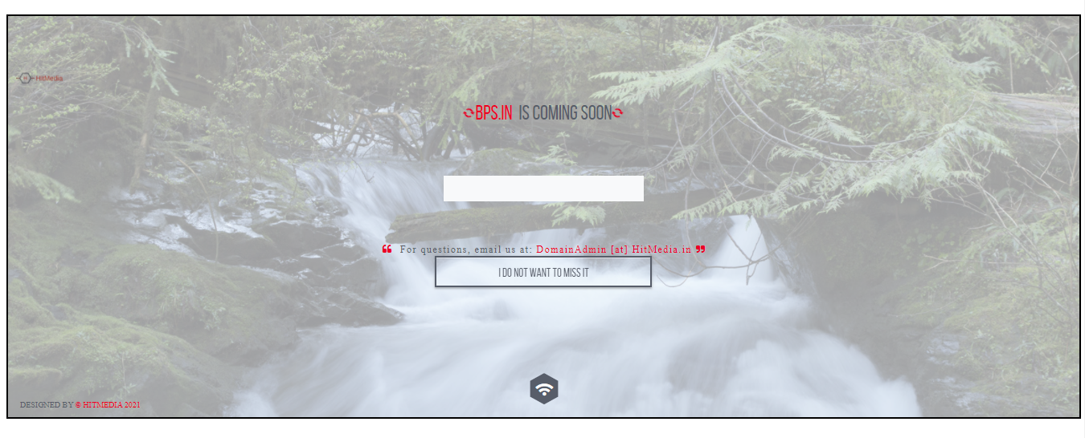

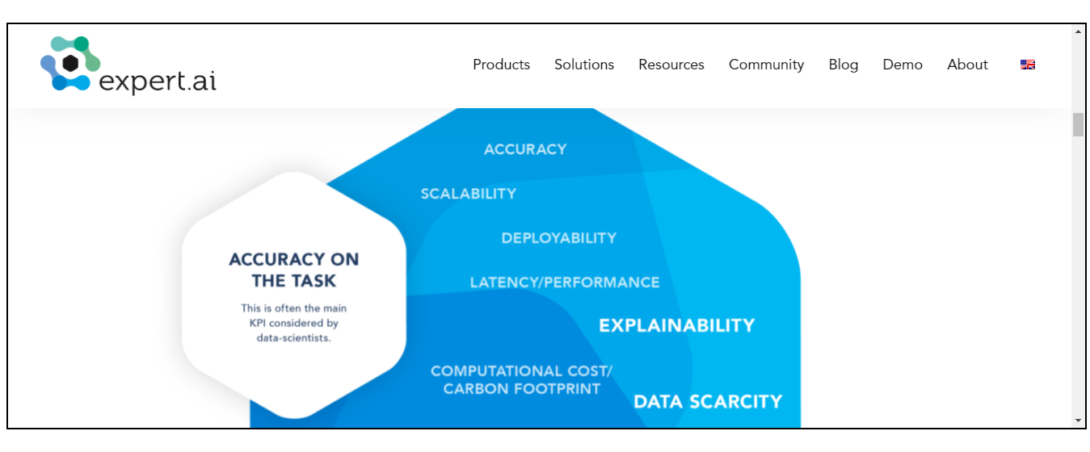

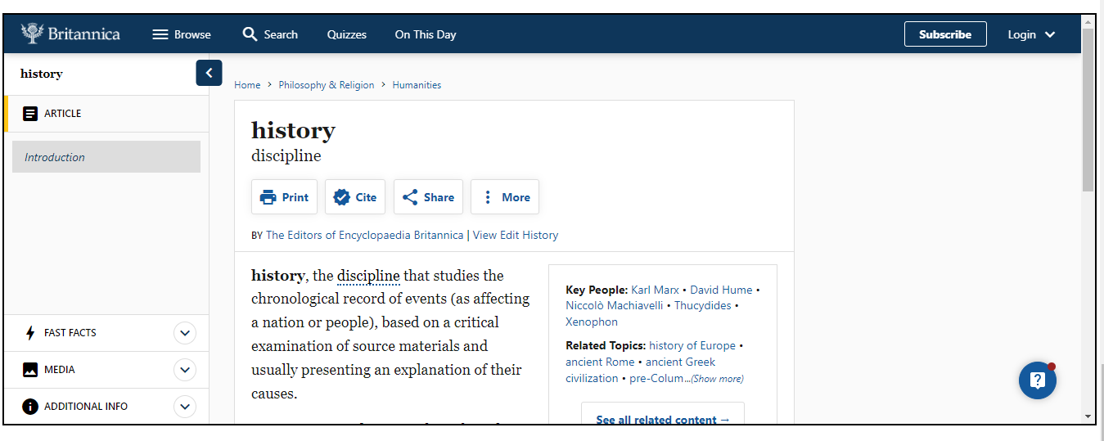

Practical 11

Code:-

<html lang="en">

<head>

<meta charset="UTF-8" />

<meta http-equiv="X-UA-Compatible" content="IE=edge" />

<meta name="viewport" content="width=device-width, initial-scale=1.0" />

<title>Frameset</title>

<style>

a {

text-decoration: none;

color: black;

text-align: left;

font-weight: bolder;

font-family: Cambria, Cochin, Georgia, Times, "Times New Roman", serif;

}

</style>

</head>

<body>

<header style="border: 1px solid black">

<h3 style="display: inline">

<img

style="margin-left: 20px; margin-bottom: 10px"

src="Media/National_Institute_of_Open_Schooling.png"

width="8%"

alt=""

/>

</h3>

<h1

style="

display: inline;

margin-left: 20%;

position: absolute;

line-height: 40px;

top: 20px;

"

>

National Institute of Open Schooling (NIOS)

<br />

<span style="font-size: x-large; margin-left: 20%">

B-31B, Kailash Colony, New Delhi-18</span

>

<br />

<span style="font-size: x-large; margin-left: 22%">

Website:

<a

style="text-decoration: none; color: black"

target="_blank"

href="https://www.nios.ac.in"

>https://www.nios.ac.in</a

>

</span>

</h1>

</header>

<table style="border: 1px solid black">

<tr>

<td style="border-right: 1px solid black; padding-right: 70px">

<ul>

<li>

<a

href="https://www.nios.ac.in/departmentsunits/academic.aspx"

target="frame"

>Academic Programmes</a

>

</li>

<br /><br />

<li>

<a

href="https://www.nios.ac.in/departmentsunits/vocational-education.aspx"

target="frame"

>Vocational Education</a

>

</li>

<br /><br />

<li>

<a

href="https://www.nios.ac.in/notice-boardoffice-order.aspx"

target="frame"

>Examination</a

>

</li>

<br /><br />

<li>

<a

href="https://www.nios.ac.in/departmentsunits/administration.aspx"

target="frame"

>Administration</a

>

</li>

<br /><br />

<li>

<a

href="https://sdmis.nios.ac.in/registration/locate-study-center"

target="frame"

>Study Center</a

>

</li>

<br /><br />

<!-- <li><a href="" target="frame">FAQ</a></li><br><br> -->

<li>

<a href="https://www.nios.ac.in/contact-us.aspx" target="frame"

>Contact us</a

>

</li>

</ul>

</td>

<td>

<iframe

src=""

frameborder="0"

title="Right frame"

name="frame"

width="1100px"

height="585px"

>

</iframe>

</td>

</tr>

</table>

<footer>

<h3 style="text-align: center; border: 1px solid black; margin: 0%">

Website Designed & Developed By

<a target="_blank" href="https://www.nios.ac.in"

>National Institute of Open Schooling (NIOS)</a

>

<br />

For any Query Contact

<a target="_blank" href="https://linktr.ee/imamantripathi"

>Aman Tripathi</a

>

</h3>

</footer>

</body>

</html>

Output:-

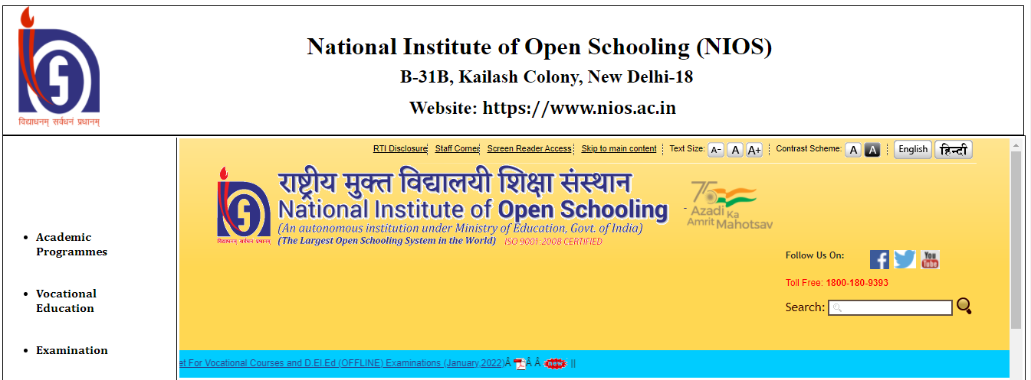

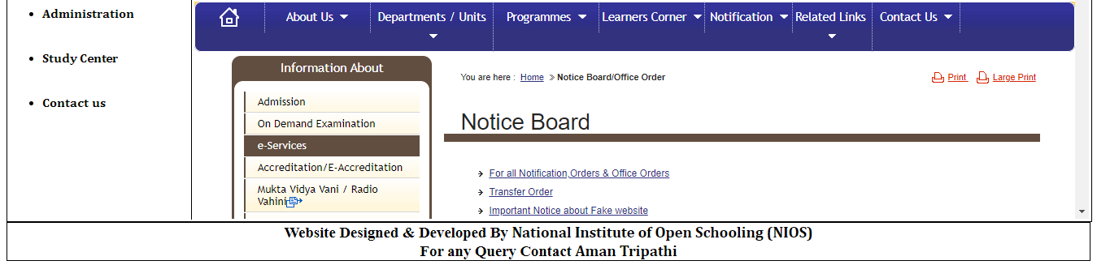

Practical 12

Code:-

<!DOCTYPE html>

<html lang="en">

<head>

<meta charset="UTF-8" />

<meta http-equiv="X-UA-Compatible" content="IE=edge" />

<meta name="viewport" content="width=device-width, initial-scale=1.0" />

<title>Iframe Example</title>

</head>

<body style="border: 1px solid black; padding: 10px">

<h3>

The Taj Mahal'Crown of the Palace' is an ivory-white marble mausoleum on

the right bank of the river Yamuna in the Indian city of Agra. It was

commissioned in 1632 by the Mughal emperor Shah Jahan (r. 1628–1658) to

house the tomb of his favourite wife, Mumtaz Mahal; it also houses the

tomb of Shah Jahan himself. The tomb is the centrepiece of a 17-hectare

(42-acre) complex, which includes a mosque and a guest house, and is set

in formal gardens bounded on three sides by a crenellated wall.

</h3>

<iframe

src="https://upload.wikimedia.org/wikipedia/commons/thumb/d/da/Taj-Mahal.jpg/200px-Taj-Mahal.jpg"

width="200px"

height="133px"

frameborder="4"

>

</iframe>

<h3>

he most spectacular feature is the marble dome that surmounts the tomb.

The dome is nearly 35 metres (115 ft) high which is close in measurement

to the length of the base, and accentuated by the cylindrical "drum" it

sits on, which is approximately 7 metres (23 ft) high. Because of its

shape, the dome is often called an onion dome or amrud (guava dome).[19]

The top is decorated with a lotus design which also serves to accentuate

its height. The shape of the dome is emphasised by four smaller domed

chattris (kiosks) placed at its corners, which replicate the onion shape

of the main dome. The dome is slightly asymmetrical.[20] Their columned

bases open through the roof of the tomb and provide light to the interior.

Tall decorative spires (guldastas) extend from edges of base walls, and

provide visual emphasis to the height of the dome. The lotus motif is

repeated on both the chattris and guldastas. The dome and chattris are

topped by a gilded finial which mixes traditional Persian and Hindustani

decorative elements.[21] The main finial was originally made of gold but

was replaced by a copy made of gilded bronze in the early 19th century.

This feature provides a clear example of integration of traditional

Persian and Hindu decorative elements.[22] The finial is topped by a moon,

a typical Islamic motif whose horns point heavenward.[23] The minarets,

which are each more than 40 metres (130 ft) tall, display the designer's

penchant for symmetry. They were designed as working minarets— a

traditional element of mosques, used by the muezzin to call the Islamic

faithful to prayer. Each minaret is effectively divided into three equal

parts by two working balconies that ring the tower. At the top of the

tower is a final balcony surmounted by a chattri that mirrors the design

of those on the tomb. The chattris all share the same decorative elements

of a lotus design topped by a gilded finial. The minarets were constructed

slightly outside of the plinth so that in the event of collapse, a typical

occurrence with many tall constructions of the period, the material from

the towers would tend to fall away from the tomb.[24]

</h3>

</body>

</html>

Output:-

